Game Design Document

Gromov Alexander (20218463)

DSU International College

Game Programing

Puzzle-platformer “The Orb”

The Orb 3

Game overview: 3

Game Concept: 3

Target audience: 3

Genres: 3

Game flow summary: 3

Visual style: 3

Gameplay: 3

Progression: 3

Objectives: 3

Play flow: 3

Mechanics: 3

Controls: 3

Difficulty: 3

Replaying: 3

Character: 3

Selling points: 3

Levels 4

Levels: 4

Interface: 4

Visual system: 4

Control system: 4

Technical 6

Hardware requirement: 6

Development hardware: 6

Development Software: 6

Network requirements: 6

Audio 6

Sfx: 6

Music: 6

Reference games 6

Bounce 6

Work plan 7

March 2024: 7

April 2024: 7

May 2024: 7

June 2024: 7

The Orb

Orb is a 2d game that incorporates elements from puzzle and platformer games. Player is given a set of levels that must be solved using game mechanics and physics.

Game overview:

Game Concept: a 2D puzzle platformer with physics elements.

Target audience: Casual players, fans of platformers like Bounce.

Genres: 2D platformer, puzzle.

Game flow summary: player selects a level that will be loaded and tries to complete it by moving an orb, dodging spikes, overcoming obstacles and using physics to help them while collecting bonuses on the way, which combined with remaining lives will determine the amount of stars player gets on the score screen.

Visual style: 2D pixel-art. Simple yet cohesive and enjoyable.

Gameplay:

Progression: Upon completing a level player gets access to a new level. If the player completes all levels with maximum stars, access to a secret level will be given.

Objectives: to complete all levels

Play flow: Player starts a game, selects a level and then tries to complete it. After that they return on level selector and can select another level to play.

Mechanics:

Controls: player moves the orb sideways and upwards with jumps.

Difficulty: First few levels will introduce the mechanics one by one. This will also introduce health points, which adds together with bonus points on the level to give the stars in the end of the level.

Replaying: Each level has infinite amount of tries and can be replayed anytime.

Character: a small orb colored by player’s choosing.

Selling points: the game has no violence and can be used to educate children the basic concepts of physics and help familiarize with them.

Game can also be competitive since players get stars when finishing level and that can be shared among friends.

Levels

Levels: First one will show the basic controls: jump and roll sideways. The second will explain water, shows that medium and big sized orb floats on the top while small drowns. The third level introduces wind and that only big orb can fly catching the wind. The fourth will introduce spikes, they are either small (then the big and medium orb can roll on them safely), medium (the small orb can get under them unharmed with certain precision while the big orb simply rolls over) and big (both small and medium orb can get between spikes). After those levels will combine elements introduced in tutorials (spikes, wind tunnels, water, obstacles) gradually increasing in difficulty. Final level before the secret level will be testing the player and skills acquired after playing all other levels. The secret level will be revealed after completing all levels and getting maximum stars. The level itself will be just a thank you for playing and maybe show early stages of the game’s development.

Interface:

Visual system: there will be a main menu, which has buttons like Play, Settings, Save/Load and Exit, but mostly is just a splash screen. Then there will be a level selector, showing different levels and Then there will be an options menu, allowing to adjust graphics and other parameters. Also, there will be a save/load menu. And finally, there will be a pause menu inside each level, with access to options and save/load menu.

Control system: right and left arrows (or A and D keys) to roll sideways, up arrow/space to jump. Escape key will open a pause menu or main menu, depending if the player is currently completing a level or not.

*Figure 1: Menu flow concept*

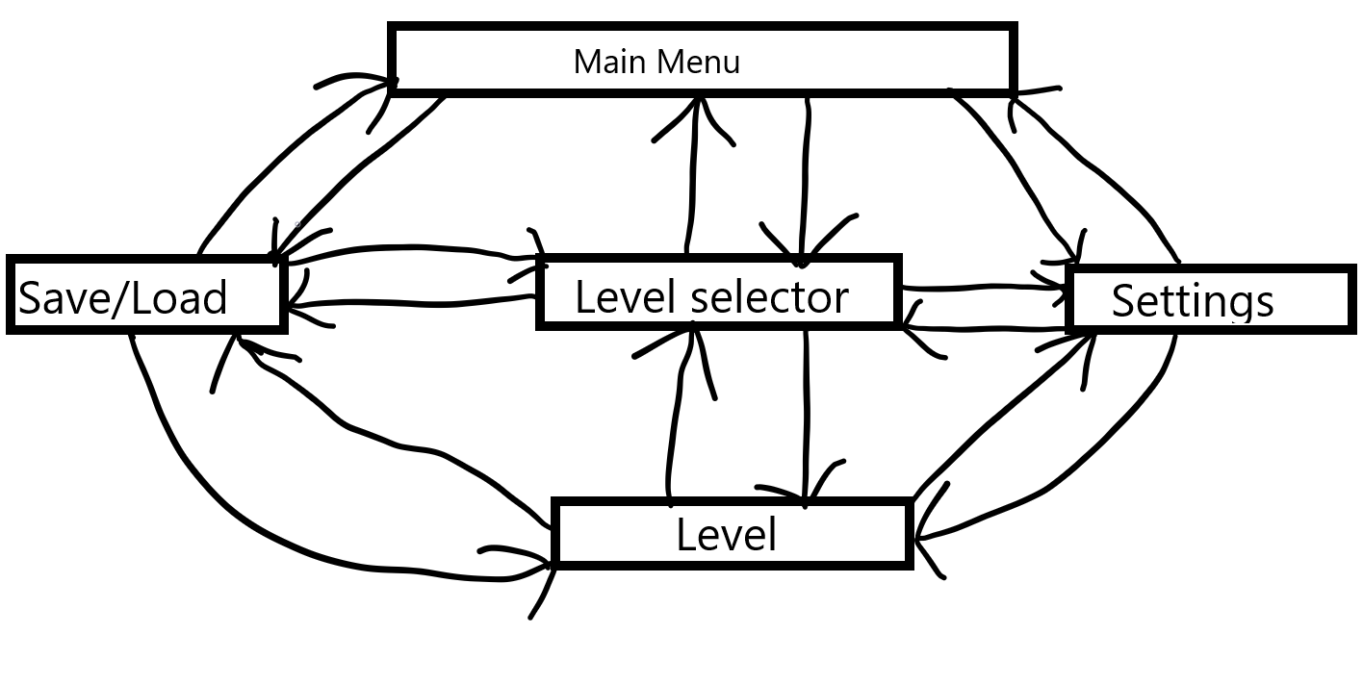

*Figure 2: Level Selector concept*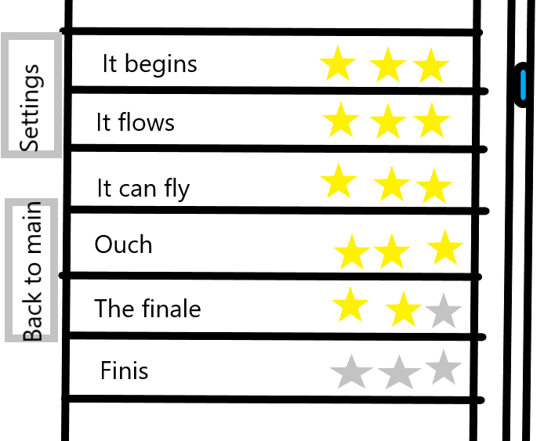

Technical

Hardware requirement: as low as possible, it’s a simple game.

Development hardware: laptop and Wacom.

Development Software: Unity 2021, Visual Studio 2022 and Paint.

Network requirements: none.

Audio

Sfx: Something simple, ball rolling sound, impact sound when touching the walls, balloon pop when impaled by spikes, some sfx when enter water or wind.

Music: simple, mostly relaxing and maybe a bit energetic, maybe a couple of my own songs.

Reference games

Bounce

*Figure 3: Bounce icon*

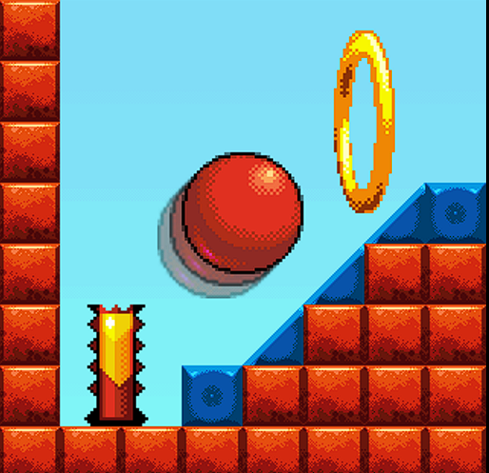

Bounce is a game that I drew inspiration from. This project aims to take general ideas from the game and expand or improve them.

Work plan

March 2024: Finish GDD, finalize idea, art direction and begin work on the prototype.

April 2024: begin rapid prototyping, implement basic elements like rolling, gravity, collision.

May 2024: Add in sfx, music, design menus, add more elements like spikes, wind tunnels, collectables, lives.

June 2024: Polishing stage, finish whatever still in progress and cut the parts that won’t be done in time before deadline.